

Tech Saksham

CaseStudyReport

DataAnalyticswithPowerBI

# “Analysis of Commercial Electricity Consuming”

**“Holy Cross Home Science College”**

|  |  |
| --- | --- |
| **NMID** | **NAME** |
| 9F96071A8E31236BD10456865728EA4E | M. SanthanaBhavani |

|  |  |
| --- | --- |
| Trainer : R.UmaMaheswari |  |
| Master Trainer : R.UmaMaheswari |  |

# ABSTRACT

In the digital age ,data has become an invaluable asset for businesses ,particularly in the banking sector. The proposed project, “Analysis of Commercial Electricity Consuming, ”aims to leverage Power BI , a leading business intelligence tool ,to analyze and visualize real-time customer data. This project will enable banks to gain deep insights into customer behavior, preferences, and trends, thereby facilitating data-driven decision-making and enhancing customer satisfaction. The real-time analysis will allow banks to respond promptly to changes in customer behavior or preferences ,identify opportunities for cross-selling and up-selling, and tailor their products and services to meet customer needs. The project will also contribute to the broader goal of digital transformation in the banking sector ,promoting efficiency, innovation, and customer-centricity.

## INDEX

|  |  |  |
| --- | --- | --- |
| **Sr.No.** | **Table of Contents** | **PageNo.** |
| 1 | Chapter1:Introduction | 4 |
| 2 | Chapter2:Services and Tools Required | 6 |
| 3 | Chapter3:Project Architecture | 7 |
| 4 | Chapter4: Modeling and Result | 9 |
| 5 | Conclusion | 18 |
| 6 | Future Scope | 19 |
| 7 | Link | 20 |

**CHAPTER 1 INTRODUCTION**

### Problem Statement:

Commercial energy use includes the consumption of the [service sector](https://www.sciencedirect.com/topics/engineering/service-sector). It is highly connected to population growth (as services tend to population serving). Commercial energy use is driven by electrical, heating, and cooling of buildings and other structures, though traffic lights, water, and [sewer systems](https://www.sciencedirect.com/topics/engineering/sewer-system) are also included in this category.5The EIA expects commercial energy use to expand by an annual 1.5% globally. Energy use will grow more quickly in developing nations, as OECD states expect much slower population growth and faster adoption of [energy efficiency measures](https://www.sciencedirect.com/topics/engineering/energy-efficiency-measure). Much of the growth in OECD electricity consumption since 1974 has taken place in the residential sector, and in the commercial and public services sector. By contrast, industry’s share of consumption has been in long-term decline with the result that as of 2019, these three sectors have a roughly equal share of consumption. The remaining consumption sectors – transport, agriculture and fishing – are relatively small consumers of electricity. However, road transport has recently experienced strong growth as electric vehicles gain market share across OECD countries, in particular in Europe.

### Proposed Solution

TheproposedsolutionistodevelopaPowerBIdashboardthatcananalyzeandvisualizeanalysis of commercial electricity consumption in Indian state data. The dashboard will integrate data from various sources such as state power consuming data. It will provide a comprehensive view of usage of electricity, before lock-down and after lockdown. The dashboard will be interactive, user-friendly, and customizable .The analysis of commercial consuming electricity is capability of the dashboard will enable to government the total consumption of electricity in Indian state.

### Feature

* **Analysis** :The dash board will provide analysis of commercial electricity consumption in Indian state.
* **Trend Analysis**: The dash board will identify and display the usage of electricity.
* **Predictive Analysis**: It will use historical data to predict future consumption of electricity.

### Advantages:

Environmental : Increased efficiency can lower green house gas(GHG) emissions and other pollutants, as well as decrease water use.

Economic : Improving energy efficiency can lower individual utility bills, create jobs, and help stabilize electricity prices and volatility.

### Scope

Based on recent data from the Central Electricity Authority(CEA),the peak power demand is expected to each 2030 GW by 2035.Meeting this demand requires strategic capacity addition and robust infrastructure development. India's electricity sector is dominated by fossil fuels, in particular coal, which produced about three-quarters of the country's electricity.[10][11]The government declared its efforts to increase investment in renewable energy. Under the government's 2023-2027 National Electricity Plan, India will not build any new fossil fuel power plants in the utility sector, aside from those currently under construction.[12][13]It is expected that non-fossil fuel generation contribution is likely to reach around 44.7% of the total gross electricity generation by 2029–30.

## CHAPTER2

**SERVICESANDTOOLSREQUIRED**

### Services Used

* + - **Data Collection and Storage Services** : Data analysis tools are software applications or libraries that allow you to apply mathematical or machine learning models to your energy data. Some examples of data analysis tools are statistical software, optimization software, and machine learning frame works like Tensor Flow or P y Torch.
    - **Data Processing Services** :Services like Azure Stream Analytics or AWSK in esis Data Analytics can be used to process the real-time data.
    - **Machine Learning Services** :Azure Machine Learning or AWSS age Maker can be used to build predictive models based on historical data.

### Tools and Software used

#### Tools:

* + - **Power BI**: The main tool for this project is Power BI, which will be used to create interactive dashboards for real-time data visualization.
    - **Power Query** :This is a data connection technology that enables you to discover, connect, combine, and refine data across a wide variety of sources.

#### Software Requirements:

* + - **Power BI Desktop** :This is a Windows application that you can use to create reports and publish them to Power BI.
    - **Power BI Service** :This is an online SaaS (Software as a Service) service that you use to publish reports, create new dashboards, and share insights.
    - **Power BI Mobile** :This is a mobile application that you can use to access your reports and dashboards on the go.

## CHAPTER 3 PROJECT ARCHITECTURE

### Architecture

* + 1. **Data Storage**: The collected data is stored in a data base for processing. Azure SQL Database or AWS RDS can be used for this purpose.
    2. **Data Processing** :The stored data is processed in real-time using services like Azure Stream Analytics or AWS Kinesis Data Analytics.
    3. **Machine Learning**: Predictive models are built based on processed data using Azure Machine Learning or A WSS age Maker. These models can help in predicting customer behavior, detecting fraud, etc.
    4. **Data Visualization** :The processed data and the results from the predictive models are visualized in real-time using Power BI. Power BI allows you to create interactive dashboards that can provide valuable insights into the data.
    5. **Data Access** :The dash boards created in Power BI can be accessed through Power BI Desktop, Power BI Service (online), and Power BI Mobile.

This architecture provides a comprehensive solution for real-time analysis of bank customers. However ,it’s import an to note that the specific architecture may vary depending on the bank’s existing infrastructure, specific requirements, and budget. It’s also important to ensure that all tools and services comply with relevant data privacy and security regulation

## CHAPTER4 RESULT

The impact of COVID-19 pandemic on electricity consumption and electricity demand forecasting accuracy compares the average electricity consumption between 2010 and 2019 with the monthly electricity consumption in pandemic years 2020 and 2021 in different socio economic groups in Qatar .The goal is to compare the pattern of electricity use during the pandemic years to that of the pre-pandemic years. Prior to the pandemic years, the highest electricity consumption occurred in summer for all sectors. This finding is due to the high demand for cooling during the extremely hot summer months. Further more, the figure evidently indicates that electricity usage is low during the beginning of the year during the winter season and starts to gradually increase until it reaches its peak during the summer and then starts to decrease at the end of the year .The residential sector's electricity usage followed the same pattern during the pandemic years. This pattern changed dramatically in the other sectors, particularly the industrial sector .In the pandemic years, the monthly electricity usage in the industrial sector was much less than the average electricity usage prior to the pandemic, demonstrating the effect of the pandemic on electricity usage in this sector.

**Dashboard**

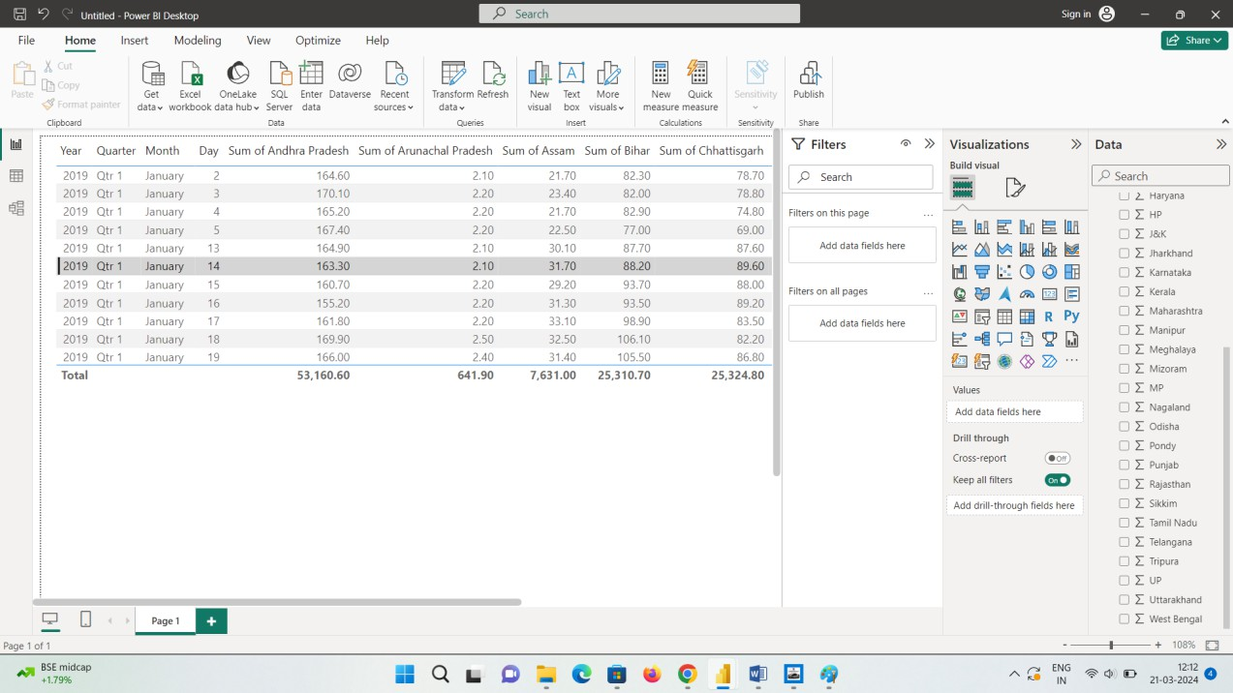

**Before Lockdown**

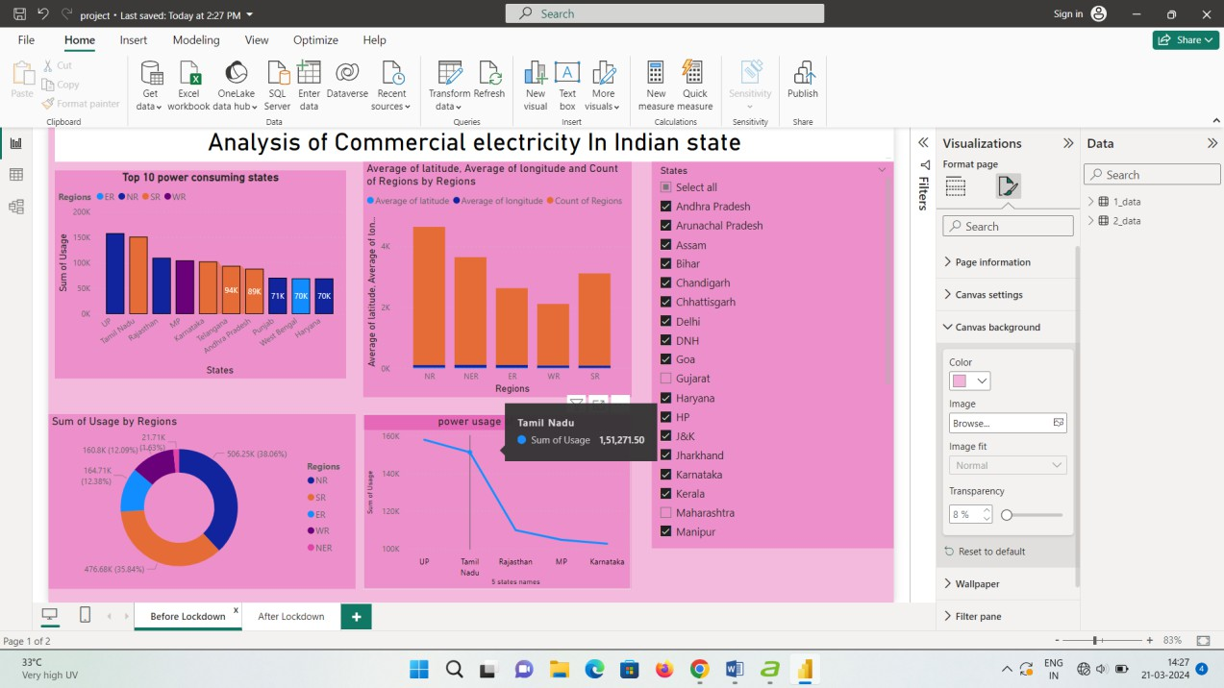

**After Lockdown**

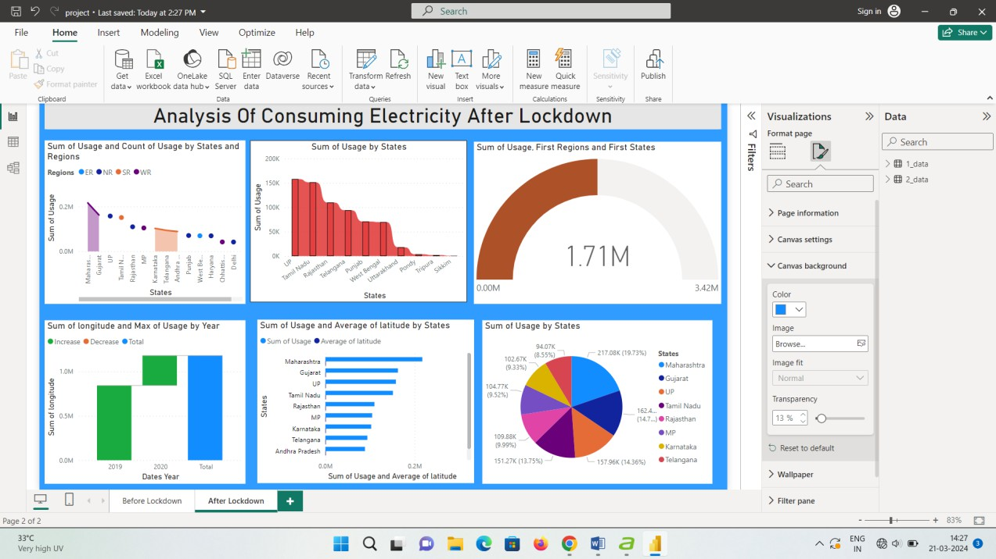

## CONCLUSION

The project “Analysis commercial electricity consumption” using Power BI has successfully demonstrated the potential of data analytics in the banking sector. The real-time analysis of customer data has provided valuable insights into customer behavior, preferences, and trends, thereby facilitating informed decision-making. The interactive dashboards and reports have offered a comprehensive view of customer data, enabling the identification of patterns and correlations. This has not only improved the efficiency of data analysis but also enhanced the bank’s ability to provide personalized services to its customers. The project has also highlighted the importance of data visualization in making complex data more understandable and accessible. The use of Power BI has made it possible to present data in a visually appealing and easy-to-understand format, thereby aiding in better decision-making.

## FUTURESCOPE

The future scope of this project is vast. With the advent of advanced analytics and machine learning, Power BI can be leveraged to predict future trends based on historical data. Integrating these predictive analytics in to the project could enable the bank to anticipate customer needs and proactively offer solutions. Further more, Power BI’s capability to integrate with various data sources opens up the possibility of incorporating more diverse data sets for a more holistic view of customers. As data privacy and security become increasingly important, future iterations of this project should focus on implementing robust data governance strategies . This would ensure these cure handling of sensitive customer data while complying with data protection regulations. Additionally, the project could explore the integration of real-time data streams to provide even

More timely and relevant insights. This could potentially transform the way banks interact with their customers, leading to improved customer satisfaction and loyalty.

**Link**

**https://github.com/bhavani-240903/power-BI-project.git**